**ENGR 102 Sect ICA L11**

**35 points**

**Reading assignment:**

|  |  |
| --- | --- |
| **Lecture Slides** | **L011** |
| **Zy Book** | *Ch11* |

*Attention!!*

*Individual submission on Canvas.*

*Submit* *by the end of the class: this file with answers and screenshots, and all your produced files.*

*No pictures by the phone – it is impossible to read. You will be allowed to resubmit and reupload HW as many times as you want to within the due date/time, only last submission will be graded. No late submissions. For submission you may use this file as template: rename file including your name. Do not forget to put your name inside of this file as well. For this submission use Individual Header.*

*# Written by Muhammad Ijaz; to be used optionally alongside Lecture9 slides by John Keyser*

*Modified by G. Tsvetkova*

**Execute these activities in Python Console**

**# <fileID> = open("<File Name>", "<designator>")****# Designators or Modes:  
# r Reading (will read data from the existing file)  
# w Writing (will write data to a new file)  
# a Appending (will append data to an existing file)  
# rb, wb, ab (will read/write/append BINARY data; we use this when we are not writing text)  
# r+ (will read from AND write to the file)  
# <nothing> (in the absence of a mode designator, r’ is the default)  
  
Start here.**

**Copy and paste the following text into a text file and save it as 'para.txt' in the current folder.**

***Make sure that each line starts separately, word file it does not keep the structure***

*# The Chronicles of Narnia is a series of seven fantasy novels by C. S. Lewis.  
# It is considered a classic of children's literature and is the author's best-known work, having sold over 100 million copies in 47 languages.  
# Written by Lewis, illustrated by Pauline Baynes, and originally published in London between 1950 and 1956, The Chronicles of Narnia has been adapted several times, complete or in part, for radio, television, the stage, and film.***Open Python new file start typing the following:**

text = open(**'para.txt'**) # you need to have para.txt before you open file for ‘r’

**###**

**Check if file extensions are visible. If they are visible, you will see *.txt, if not you won’t see the extension txt. However, in the py-file you have to use extension txt such as** para.txt

s = text.read() *# reads all the content of the file and returns it as a single string*print(s)

text.close()

**See what is printed.**

* **Change the previous lines to the following**

s = text.readline() *# reads the content of the file up to the next newline character and returns it as a single string*print(s)  
**See what is printed, notice difference.**

* **Execute the following two commands one more time**

s = text.readline() *# reads the content of the file up to the next newline character # and returns it as a single string*print(s)

**Notice: At the end of the file readline returns an empty string.**

* **Execute the following**

*# Read (and print) the whole file*text = open(**'para.txt'**)  
line = text.readline()  
**while** line != **''**:  
 print(line, end=**''**)  
 line = text.readline()  
text.close()

**See what is printed, notice difference.**

***# Another way to read (and print) the whole file***

text = open(**'para.txt'**)  
**for** line **in** text:  
 print(line)  
text.close()  
  
**Read all the lines from a file and store them into a list, and write all the strings in the list to another file**

text = open(**'para.txt'**, **'r'**)  
text_1 = open(**'para_1.txt'**, **'w'**) *# opens a new file for writing; if the file exists, it will be overwritten*lines = text.readlines() *# lines is a list of strings; another way to do this is: lines = list(text)*text_1.writelines(lines)  
  
text.close()  
text_1.close()

**Where is the output?**

**Check the new file para_1. Why you have to have para.txt created before opening it, but para_1.txt was created for you? What is the difference?**

**Read all the lines from a file, convert them to uppercase letters, and write them into another file**

text = open(**'para.txt'**, **'r'**)  
TEXT = open(**'para_C.txt'**, **'w'**)  
line = text.readline()  
**while** line != **''**:  
 LINE = line.upper()  
 TEXT.write(LINE)  
 line = text.readline()  
text.close()  
TEXT.close()

**Where is the output?**

**Check the new file para_C. Why you have to have para.txt created before opening it, but para-C.txt was created for you? What is the difference?**

**# Another way to read all the lines from a file, convert them to uppercase letters, and write them into another file**text = open(**'para.txt'**, **'r'**)  
TEXT = open(**'para_C.txt'**, **'w'**)  
**for** line **in** text:  
 TEXT.write((line.upper()))  
text.close()  
TEXT.close()  
  
**# Another way to read all the lines from a file, convert them to uppercase letters, and write them into another file**text = open(**'para.txt'**, **'r'**)  
TEXT = open(**'para_C.txt'**, **'w'**)  
  
lines = text.readlines() *# lines is a list*LINES = ( (**''**).join(lines) ).upper() *# LINES is a string; newline characters are included*TEXT.write(LINES)  
  
text.close()  
TEXT.close()

**Assignment**

**Submit this file with answers and screenshots, all your produced files.**

**Question 1 [4 points]. Why do you have to have file para.txt created before opening it, but para_C.txt was created for you? What is the difference?**

**Because para_C.txt is created from file para.text. It creates a new text file with the changes from the code while keeping the original text file.**

**Question 2 [4 points] why do you need to close file after you are done using it?**

**Because it may corrupt subsequent code or text files. If a file is not closed changes from previous code may directly effect other calls to that file.**

**Question 3.[4 points]**

**Explian 2 alternatives for opening files. When is the best to use option 1 and when option 2?**

**### OPTION 1**

myfile = open("data.dat",r+)

#Do stuff with myfile - read/write

myfile.close()

**Best for multiple files open for an extended period of time.**

**### OPTION 2**

with open("data.dat",r+) as myfile:

#Do stuff with myfile - read/write

Best for when you want the file to be closed correctly.

**Question 4. [3 points]**

**What is the difference between write command and print statement?**

**A print statement generally outputs something to a terminal screen. A write command can output something to a file or other outside source.**

**Exercise: [10 points]   
Write a program that lets a user enter a date, in a string of the form: month/day/year. The program then converts the entered date to the format mmm dd, yyyy, and displays it.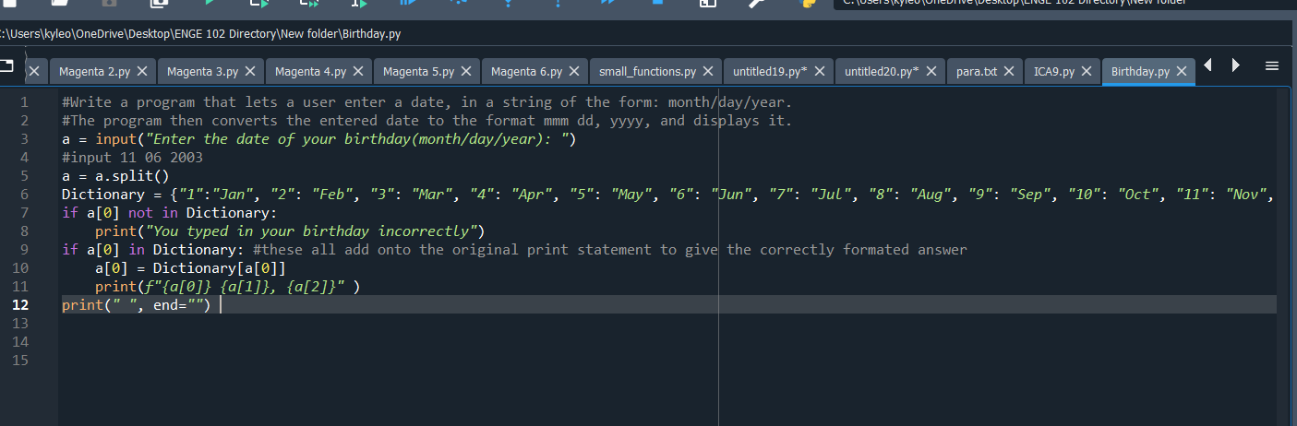Exercise: [10 points]   
Reuse your previous code, but with a file now.**

**Write a program that reads from a text file, translates into Pig Latin, and writes the translated text into another file.**

